API Version Migration

🌟 Definition
# Source: AI Source: Provided by: [Data Path: Persons Table -> ID Column: 1, Name_En Column: Motasem Essam] -> From: [ChatGPT] on [6/7/2026]
API Version Migration is the process of moving applications and clients from one version of an API to a newer version while maintaining functionality and compatibility.
It occurs when an API provider releases a new version that introduces:
- New features
- Performance improvements
- Security enhancements
- Bug fixes
- Breaking changes

🎯 Purpose
# Source: AI Source: Provided by: [Data Path: Persons Table -> ID Column: 1, Name_En Column: Motasem Essam] -> From: [ChatGPT] on [6/7/2026]
Organizations perform API version migration to:
- Access new features
- Improve security
- Fix bugs
- Improve performance
- Follow vendor requirements
- Replace deprecated API versions

🧠 Simple Definition
# Source: AI Source: Provided by: [Data Path: Persons Table -> ID Column: 1, Name_En Column: Motasem Essam] -> From: [ChatGPT] on [6/7/2026]
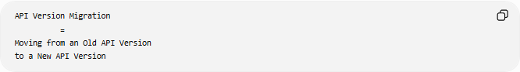
API Version Migration
=
Moving from an Old API Version
to a New API Version

📚 What is an API Version?
# Source: AI Source: Provided by: [Data Path: Persons Table -> ID Column: 1, Name_En Column: Motasem Essam] -> From: [ChatGPT] on [6/7/2026]
API providers often release multiple versions of the same API.
Example:
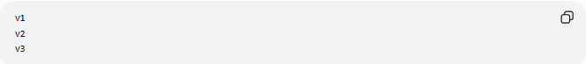
v1
v2
v3
Each version may have different:
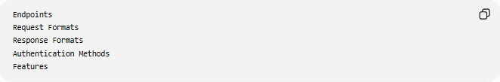
Endpoints
Request Formats
Response Formats
Authentication Methods
Features

🔍 Basic Example
# Source: AI Source: Provided by: [Data Path: Persons Table -> ID Column: 1, Name_En Column: Motasem Essam] -> From: [ChatGPT] on [6/7/2026]
Before
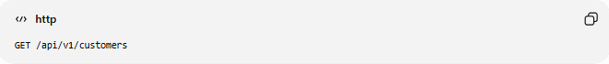
GET /api/v1/customers

After
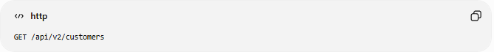
GET /api/v2/customers
The endpoint version changes from v1 to v2.

🏗️ Why API Versions Exist
# Source: AI Source: Provided by: [Data Path: Persons Table -> ID Column: 1, Name_En Column: Motasem Essam] -> From: [ChatGPT] on [6/7/2026]
API providers create new versions to:
Add Features
New Endpoints
New Parameters

Improve Security
Better Authentication
Stronger Encryption

Fix Design Problems
Cleaner Naming
Better Data Structures

Remove Obsolete Features
Deprecated Endpoints
Unused Fields

🛠️ Real-World Example
# Source: AI Source: Provided by: [Data Path: Persons Table -> ID Column: 1, Name_En Column: Motasem Essam] -> From: [ChatGPT] on [6/7/2026]
API Version 1
Request:
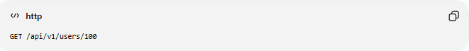
GET /api/v1/users/100
Response:
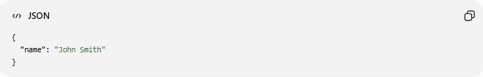
{
"name": "John Smith"
}

API Version 2
Request:
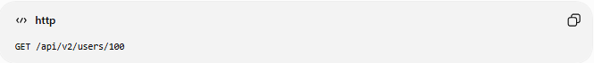
GET /api/v2/users/100
Response:
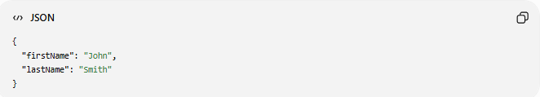
{
"firstName": "John",
"lastName": "Smith"
}

Migration Required
Applications using:
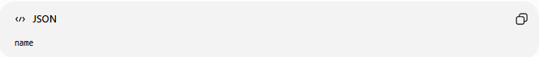
name
must be updated to use:
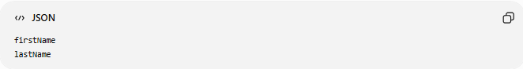
firstName
lastName

🔄 API Version Migration Lifecycle
# Source: AI Source: Provided by: [Data Path: Persons Table -> ID Column: 1, Name_En Column: Motasem Essam] -> From: [ChatGPT] on [6/7/2026]
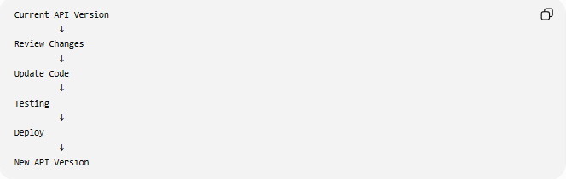
Current API Version
↓
Review Changes
↓
Update Code
↓
Testing
↓
Deploy
↓
New API Version

📦 Common Changes During Version Migration
# Source: AI Source: Provided by: [Data Path: Persons Table -> ID Column: 1, Name_En Column: Motasem Essam] -> From: [ChatGPT] on [6/7/2026]
Endpoint Changes
Before
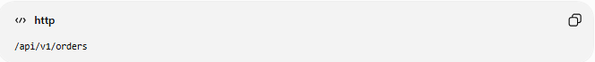
/api/v1/orders
After
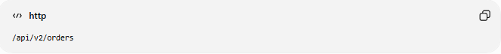
/api/v2/orders

Request Changes
Before
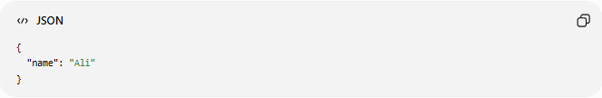
{
"name": "Ali"
}
After
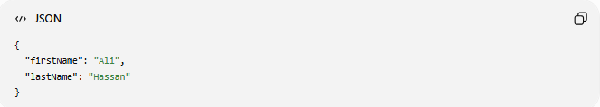
{
"firstName": "Ali",
"lastName": "Hassan"
}

Response Changes
Before
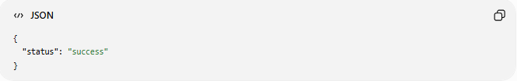
{
"status": "success"
}
After
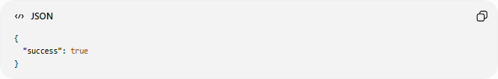
{
"success": true
}

Authentication Changes
Before
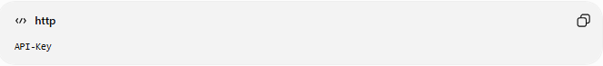
API-Key
After
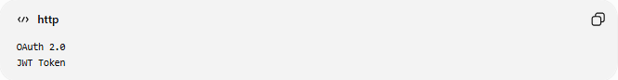
OAuth 2.0
JWT Token

🌍 Real Example
# Source: AI Source: Provided by: [Data Path: Persons Table -> ID Column: 1, Name_En Column: Motasem Essam] -> From: [ChatGPT] on [6/7/2026]
Suppose a payment provider releases:
Payment API v1
and later introduces:
Payment API v2
Changes:
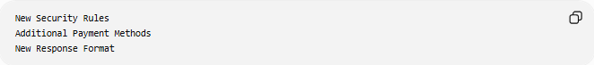
New Security Rules
Additional Payment Methods
New Response Format
Applications must migrate to continue using supported features.

⚠️ Breaking vs Non-Breaking Changes
# Source: AI Source: Provided by: [Data Path: Persons Table -> ID Column: 1, Name_En Column: Motasem Essam] -> From: [ChatGPT] on [6/7/2026]
Non-Breaking Changes
Existing clients continue working.
Example:
New Optional Field

Response:
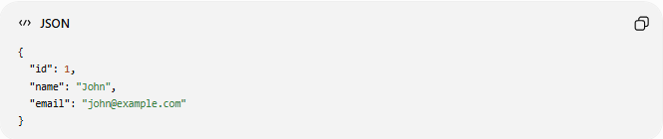
{
"id": 1,
"name": "John",
"email": "john@example.com"
}
Old applications can ignore the new field.

Breaking Changes
Existing clients stop working.
Example:
Before
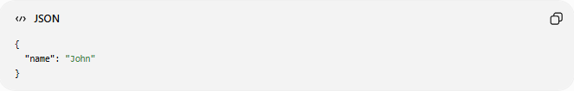
{
"name": "John"
}
After
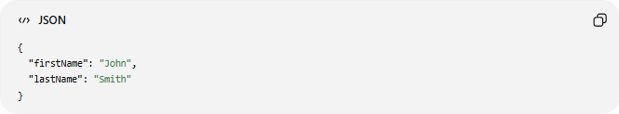
{
"firstName": "John",
"lastName": "Smith"
}
Client code must be updated.

📊 Common Versioning Strategies
# Source: AI Source: Provided by: [Data Path: Persons Table -> ID Column: 1, Name_En Column: Motasem Essam] -> From: [ChatGPT] on [6/7/2026]
URI Versioning
Version in the URL.
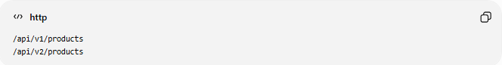
/api/v1/products
/api/v2/products
Most common approach.

Header Versioning
Version in HTTP headers.
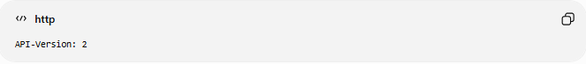
API-Version: 2

Query Parameter Versioning
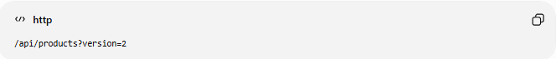
/api/products?version=2

Media Type Versioning
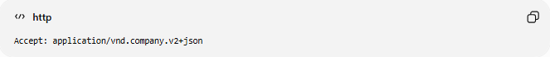
Accept: application/vnd.company.v2+json

🛠️ Migration Example
# Source: AI Source: Provided by: [Data Path: Persons Table -> ID Column: 1, Name_En Column: Motasem Essam] -> From: [ChatGPT] on [6/7/2026]
Old API Call
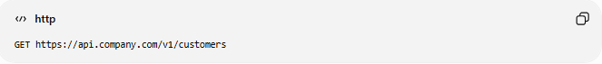
GET https://api.company.com/v1/customers

New API Call
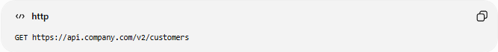
GET https://api.company.com/v2/customers

Old Response
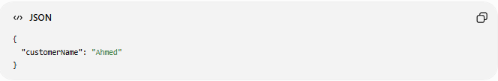
{
"customerName": "Ahmed"
}

New Response
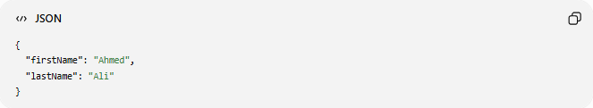
{
"firstName": "Ahmed",
"lastName": "Ali"
}

Application Update
Before
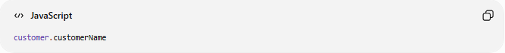
customer.customerName
After
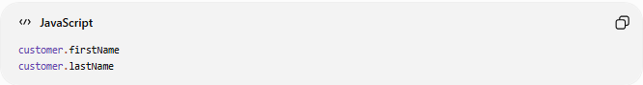
customer.firstName
customer.lastName

✅ Benefits
# Source: AI Source: Provided by: [Data Path: Persons Table -> ID Column: 1, Name_En Column: Motasem Essam] -> From: [ChatGPT] on [6/7/2026]
Access New Features
New Endpoints
New Capabilities

Improved Security
Modern Authentication
Updated Standards

Better Performance
Faster APIs
Optimized Responses

Vendor Support
Supported Versions
Security Updates

⚠️ Common Challenges
# Source: AI Source: Provided by: [Data Path: Persons Table -> ID Column: 1, Name_En Column: Motasem Essam] -> From: [ChatGPT] on [6/7/2026]
Breaking Changes
Existing code may fail.

Testing Requirements
All API integrations must be tested.

Documentation Updates
Developers need updated documentation.

Client Coordination
Multiple applications may depend on the API.

Downtime Risks
Incorrect migrations may disrupt services.

📊 API Version Migration vs API Provider Migration
# Source: AI Source: Provided by: [Data Path: Persons Table -> ID Column: 1, Name_En Column: Motasem Essam] -> From: [ChatGPT] on [6/7/2026]
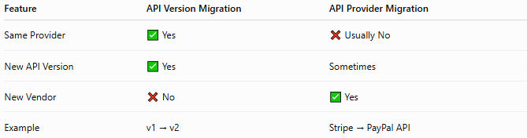
Feature | API Version Migration | API Provider Migration
Same Provider | ✅ Yes | ❌ Usually No
New API Version | ✅ Yes | Sometimes
New Vendor | ❌ No | ✅ Yes
Example | v1 → v2 | Stripe → PayPal API

API Version Migration
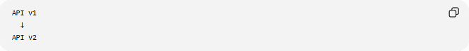
API v1
↓
API v2

API Provider Migration
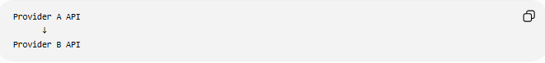
Provider A API
↓
Provider B API

🧠 Simple Analogy
# Source: AI Source: Provided by: [Data Path: Persons Table -> ID Column: 1, Name_En Column: Motasem Essam] -> From: [ChatGPT] on [6/7/2026]
Think about upgrading a mobile app.
Before
App Version 1

After
App Version 2
The app may have:
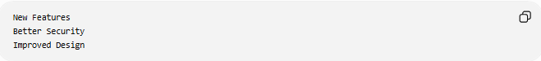
New Features
Better Security
Improved Design
but users may need to adjust to some changes.
API version migration works the same way:
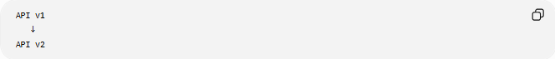
API v1
↓
API v2
Applications update their integrations to work with the newer API version.

🧭 Summary
# Source: AI Source: Provided by: [Data Path: Persons Table -> ID Column: 1, Name_En Column: Motasem Essam] -> From: [ChatGPT] on [6/7/2026]
API Version Migration is a type of API migration where applications move from one version of an API to another (e.g., v1 → v2). The migration may involve updating endpoints, request formats, response structures, authentication methods, and client code. Its goal is to gain access to new features, security improvements, performance enhancements, and ongoing vendor support while maintaining compatibility with business processes.

